Influencing and Guiding Players

Game Selected: Grim Fandango (PC, PS4, Android, iOS)

# Overview

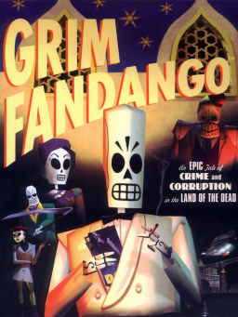Grim Fandango is an adventure game developed and released for PC, PlayStation 4, Android iPad and iPhone. The game is revolutionary in the adventure game genre in which it was the first adventure game to use 3D computer graphics which were overlaid on pre-rendered static backgrounds. The game combines elements of the Aztec belief of the afterlife with Film Noir style.

The game is set in the Land of the Dead, through which recently departed souls (which are represented as Calaca-like figures or skeleton figures) are desperately trying to reach the Ninth Underworld (the land of eternal rest). The game story revolves around the main character Manuel “Manny” Calavera as he attempts to save new arrival Mercedes “Meche” Colomar, a virtuous soul on her journey to the Ninth Underworld.

In the game, the player navigates the player through environments (keyboard and mouse for PC, controller for PS4 and touchpad for tablets/phones) progressing through levels by collecting and using items, solving puzzles, engaging with the various characters in-game and navigating through levels by completing objectives which enable the player to advance through the game

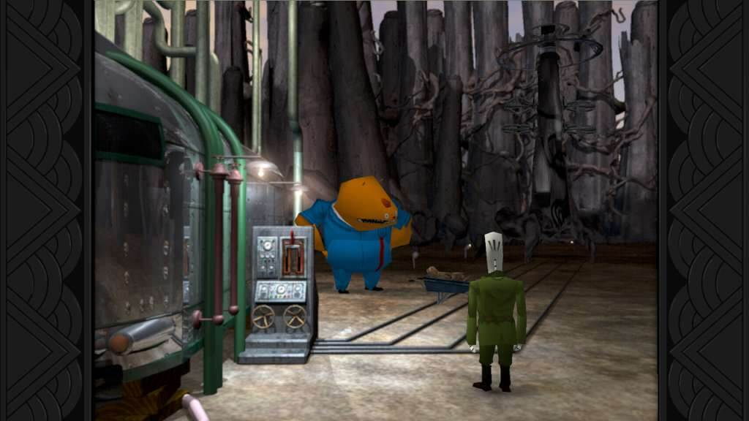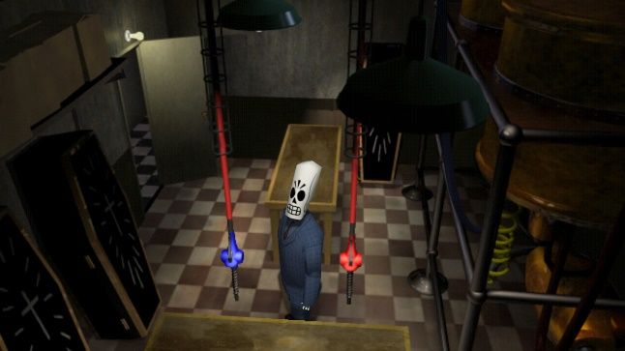  
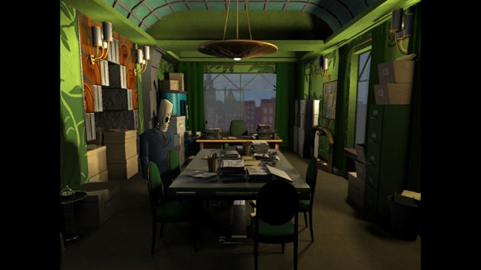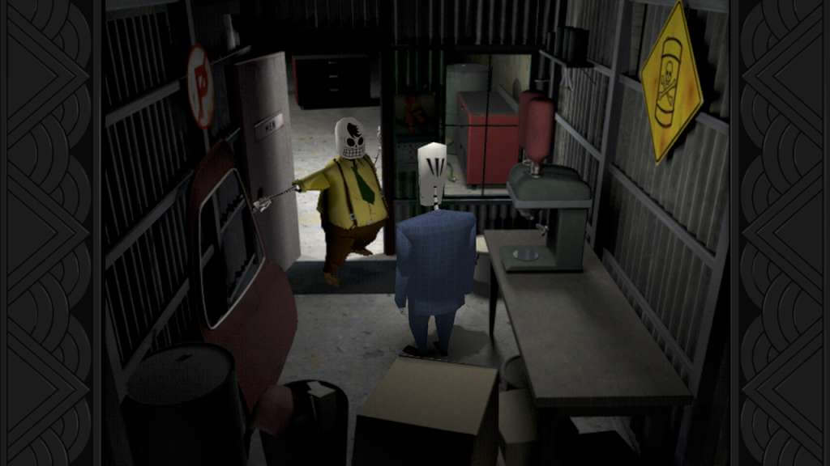

Gameplay link: <https://youtu.be/OaV0ZaFd7iQ>

# Proposal

The proposal focuses on a level in the game. The level being focused on is the first-year section in the third of four parts in the level, in which the main character Manny Calavera and his friend Glottus are trying to navigate their way through the Forbidden Forest to reach the town of Rubacava. The section involves using items, traversing the environment, solving puzzles and performing actions that allow the player to progress through the game.

The proposal involves an addition of means of influencing and guiding players through the chosen section of the level, as there are no such means present in the level. The additions will include alterations to layout, prop placement, lighting and certain changes to dialogue to act as invisible instructions to help guide the player through the level.

# Implementation and Reasoning

Some parts in this level are self-explanatory, though some parts will result in increased player friction. The changes are separately listed to go into detail with each change.

* Alteration 1:  
  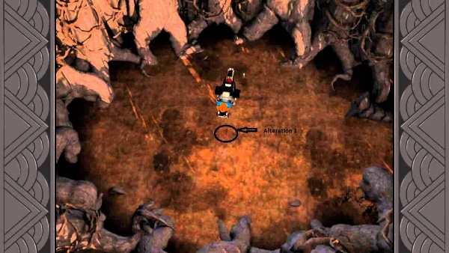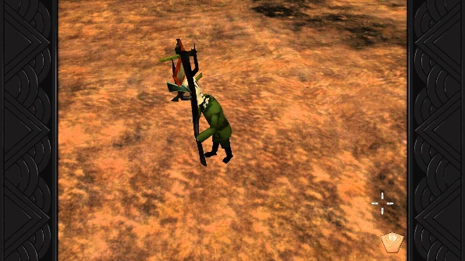  
  The first alteration involves opening a passageway in this opening that allows the Bone Wagon (transport) to go through in order to obtain a key needed to open a gate in order to progress through the level. This involves carrying a sign from another area of the map to the opening and placing it in a certain part in the middle in order to open the passageway. This part has no means of informing the player on what to do for this part, including no means on where to place the sign.   
  The alterations include a coloured hole placed exactly where the sign is meant to be placed, but not to look too obvious. The area surrounding it is more lit that the outside area of the opening so as to lead the player into the centre. The player will move the character where the hole is, where the character will say “Hmm… Looks like something fits in here”. Which will prompt the character to find the correct item to place in the hole.
* Alteration 2  
  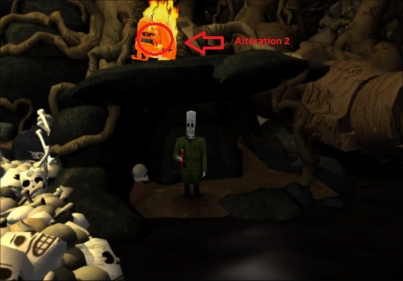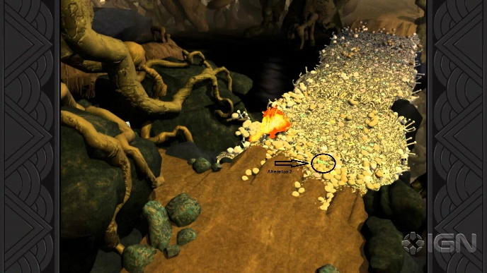  
  The second alteration involves clearing flaming beavers from a dam in order to cross it unharmed. It involves the player luring the beavers into the oily water by throwing bones in the water, and then being able to use the fire extinguisher on the beavers before they hit the water. At present, there is no indication on what the player has to do in order to complete this task in order to move forward in the game.  
  The alteration includes the player walking towards the beavers on the dam, with the character saying “Hmm… Surely there’s a way to put these beavers out somehow”. Eventually the player navigates to the oily water as shown in the first picture. As the beaver walks on the top ledge, the player will be prompted to look into the inventory, in the which they’ll select the fire extinguisher. In this case, the character will look at the beaver and say, “I could make him take a dive somehow?” This will prompt the player to return to the dam and locate and pick up a loose bone that’s already differently coloured from the rest so as to stand out.   
  The player will then return to the oily water, where thanks to the prompts said before, will throw the bone into the water, then using the fire extinguisher to put out the beavers in order to progress through the level.